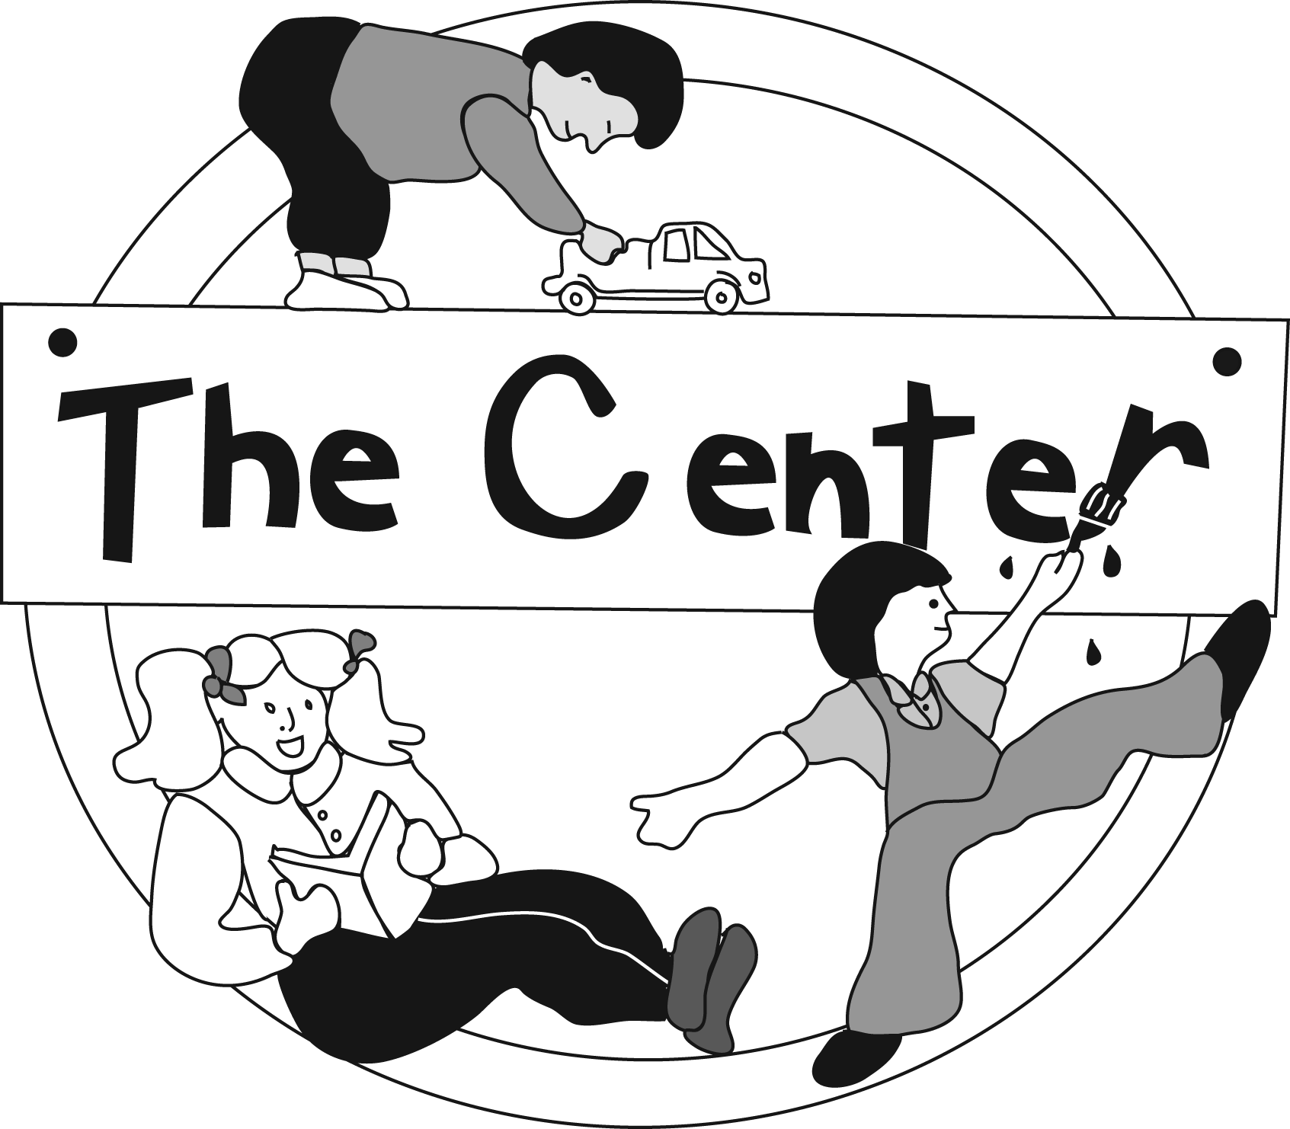
The Center
315 West 6th Street
Leadville, CO 80461

Phone 719 486-6928
Fax 719 486-9992
Early Childhood Programs
Lake County School District R-1

Head Start, Colorado Preschool Program, Tuition-Based Preschool and School Age Programs, Services for Children with Special Needs

October 16, 2019

Dear Center Families,

The preschool years are very important. We want your child to be as ready as possible for kindergarten. This is not just about knowing letters and numbers. It’s also about knowing how to learn and get along with others. We will be using Second Step Early Learning program in your child’s classroom to teach these important skills.

The Second Step program teaches skills in the following areas:

- Skills for Learning: Children gain skills to help them be better learners, including how to focus their attention, listen carefully, and ask for help.
- Empathy: Children learn to identify and understand their own and others’ feelings. Children also learn how to show care for others.
- Emotion Management: Children learn how to calm down when they have strong feelings, such as worry or anger.
- Friendship Skills and Problem Solving: Children learn how to make and keep friends and to solve problems with others in a positive way.

Your child will be learning a lot this year – and they will need your help! Throughout the year, your child will be bringing home Home Links that go with each of the Second Step weekly themes. Home Links are simple, fun activities for you and your child to do together. They are a great way for you to understand what your child is learning and for your child to show what they know.

I would be happy to answer any questions you have about Second Step program. Thank you for supporting your child in learning the skills that will help get them ready for school and life.

Sincerely,

Holly DeBell
Director, Early Childhood Programs

