FCI CONSTRUCTORS, INC.
WEST PARK ELEMENTARY

WEST PARK ELEMENTARY
SUPERINTENDENT WEEKLY ACTIVITY REPORT

Report Number 3
Week of 6/6/20 - 6/12 /20
Superintendent: Larry Yeager
Author: Jarred Collom

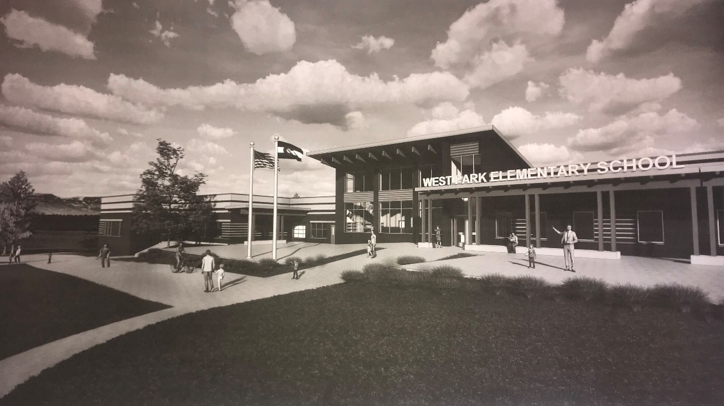

CURRENT CONSTRUCTION ACTIVITIES

Enabling Site Work
- Over Lot Grading cut/fill
- Pad and Footing Excavation
- Underground Utility Install
- Pour slab for Water Fill Station
- Begin Footing Formwork

CONSTRUCTION ACTIVITIES IMAGES
MANPOWER COUNT
Trade Partners | Responsibility | Manpower Count
FCI Constructors, Inc. | General Contractor | 3
Schofield | Site Capture/Earthwork/Utilities | 8
RMS Concrete | Forming | 10
 | Total: | 21

WEATHER CONDITIONS

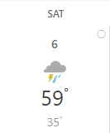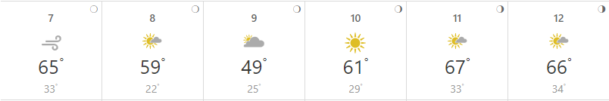

- Weather days this week: 0
- Weather days to date: 0
UPCOMING WEATHER RISKS
- Currently, no weather risks are forecasted.

SAFETY REPORT
- Lost Time Accidents to Date = 0
- Accidents This Week = 0
- Days Without Lost Time = 36

INSPECTIONS/TESTING REPORT
- All inspection parties present for their responsibilities
  - Soil Compaction Testing (Ground Engineering) - ongoing

NEXT WEEK’S ACTIVITIES
Site Work
- Pad and Footing Excavation
- Underground Utility Install
- Begin Sanitary Sewer Installation
- Prep Footings for Existing Play Area
- Prep Footings for New ECE
- Water Fill Station Relocation
- Water Line Tap
- Form and Pour Footings

