Lake County School District R-1
Benefits List
2022-2023
Certified/Support Staff
These benefits and costs are subject to change:
- Personal Time Off – 12 days each year / Annual leave for 220-240 day employees / AFSCME 12 PTO and 12 paid holidays
- Unused Personal Leave Reimbursement (up to 5 per year for non-AFSCME employees)
- Unused PTO: Rolled to personal accumulated sick leave for use as necessary should employee exhaust current year PTO
- PERA – Public Employees’ Retirement Program (Mandatory- District contributes 21.4%; Employee contributes 11%)
- Medical, Dental and Vision Insurance
- Life Insurance - $20,000 paid for by District
- Sick Leave Bank for qualifying employees
- Flex Plan – IRS 125 plan
- Child Care Discount at the Center
*AFSCME contract contains additional details *LCEA contract contains additional details
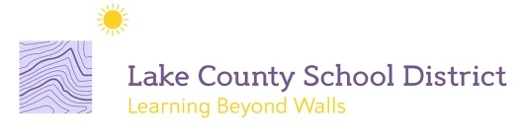
Questions? Contact Kathleen: 719 293 4678!

